**Title Page: cs 1011-051 – Lab 3 Conditionals**

Cody Mott

9/27/22

**I. Objectives**

The objective of the program is to calculate estimated taxes owed based on users filing status and income.

**II. Requirements**

* ask users to enter filing status
* ask users to enter income
* accurately calculated estimated taxes owed
* display taxes owed

**III. Design:**

//CalculateTaxes Pseudocode//

declare global variables

call getFilingStatus();

call getIncome();

call calculateTaxesOwed();

call displayTaxes();

//getFilingStatus Pseudocode//

ask user for filing status

//getIncome Pseudocode//

ask user for income

//calculateTaxesOwed Pseudocode//

if filer is single

call singleFilerTaxes();

else if user is filing jointly

call jointFilerTaxes();

else

print error message

//singleFilerTaxes Pseudocode//

initialize local variables

define tax bracket income thresholds

calculate maximum taxes per tax bracket

calculate taxes owed

//jointFilerTaxes Pseudocode//

initialize local variables

define tax bracket income thresholds

calculate maximum taxes per tax bracket

calculate taxes owed

//displayTaxes Pseudocode//

display taxes owed

**III. Test Plan/Test Strategy**

Each method was tested individually. Every time I wrote a new method or a new calculation, I ran the code to see if it functioned properly or gave accurate results. With every calculation, I checked my programs results by doing the calculations by hand and with a calculator.

**IV. Results**

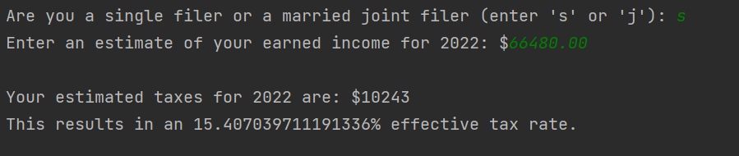

**V. Discussion**

After successfully writing the program without arrays, I challenged myself and rewrote it with arrays. I did this because arrays make code much more compact, and they also allow you to do calculations with loops.